**Python Basics for beginners**

**Step 1:**

Install Python3.6.2 (Link: <https://www.python.org/downloads/>)

**Step 2:**

Type “help”, "copyright", "credits" or "license" to get detailed information.

**Step 3:**

Perform simple instructions on the Interpretter

Use Command Prompt, IDLE or **Notepad++**

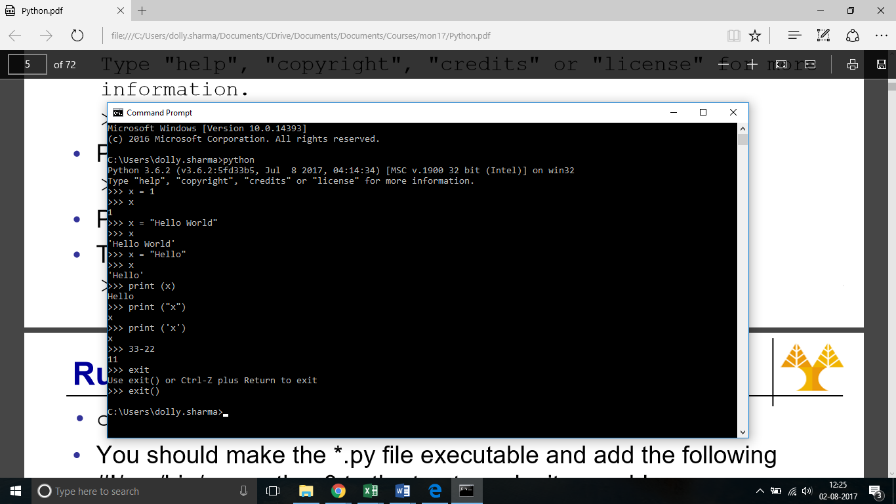

How to take user input:

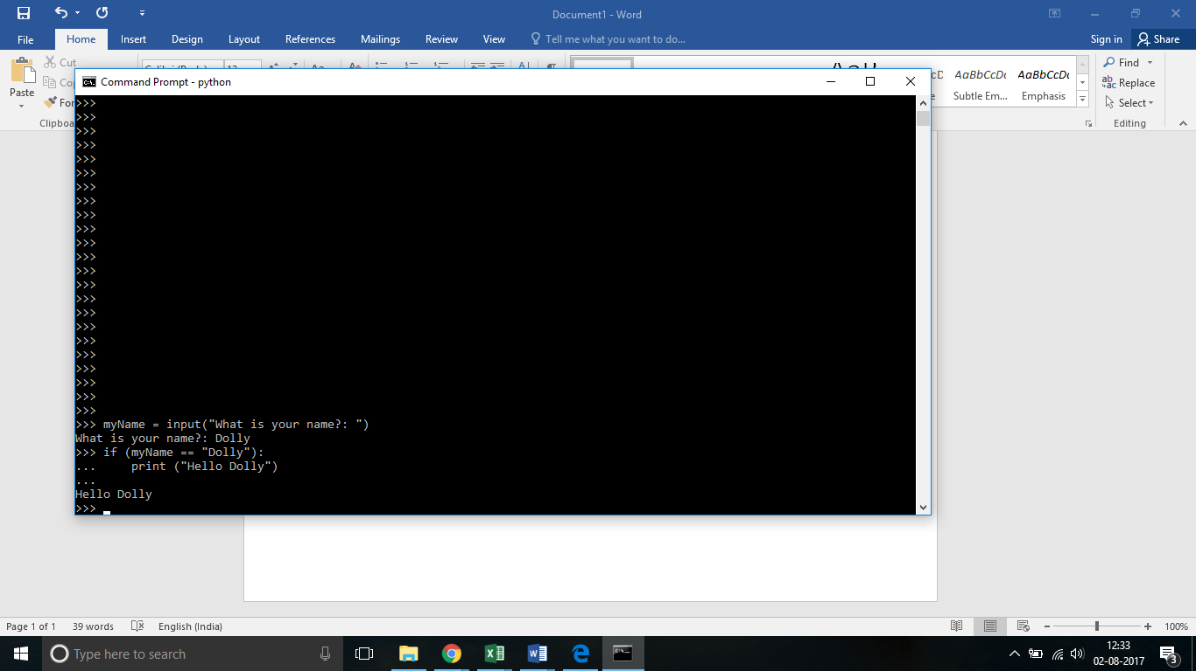

**Conditional statements:**

Sample Code 1 (if condition)

x = 55-44

y = "Hello"

z = 44

if (x == 11 or y == "Hello"):

x = x + 1

y = y + " World"

print(x)

print(y)

x = y

print(x)

Sample Code 2 (if else)

x = 55-44

y = "Hello"

z = 44

if (x == 11 or y == "Hello"):

x = x + 1

y = y + " World"

else:

y = y + “Dear”

print(x)

print(y)

x = y

print(x)

Sample Code 3 (elif)

x = 55-44

y = "Hello"

z = 44

if (x == 12):

x = x + 1

y = y + " World"

elif (x==11):

y = y + “Dear”

else:

x = x-1

print(x)

print(y)

x = y

print(x)

**List of Arithmatic operators**

|  |  |
| --- | --- |
| **Operation** | **Result** |
| x + y | sum of *x* and *y* |
| x – y | difference of *x* and *y* |
| x * y | product of *x* and *y* |
| x / y | quotient of *x* and *y* |
| x // y | floored quotient of *x* and *y* |
| x % y | remainder of x / y |
| -x | *x* negated |
| +x | *x* unchanged |
| abs(x) | absolute value or magnitude of *x* |
| int(x) | *x* converted to integer |
| float(x) | *x* converted to floating point |
| complex(re, im) | a complex number with real part *re*, imaginary part *im*. *im* defaults to zero. |
| c.conjugate() | conjugate of the complex number *c* |
| divmod(x, y) | the pair (x // y, x % y) |
| pow(x, y) | *x* to the power *y* |
| x ** y | *x* to the power *y* |

**Python Tutorial**

Please refer to <https://docs.python.org/3/tutorial/index.html>